**Analysis and findings**

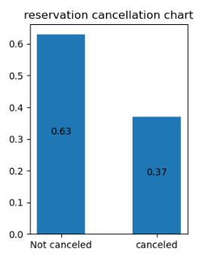

Above chart shows reservation cancelation is 37% which is quiet huge. We will deep dive into cancelation data to know more insights.

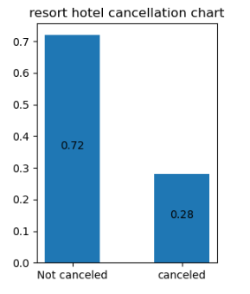 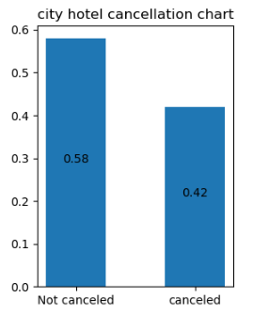

Above chart shows cancelation rate is higher in City hotel as compare to Resort hotel.

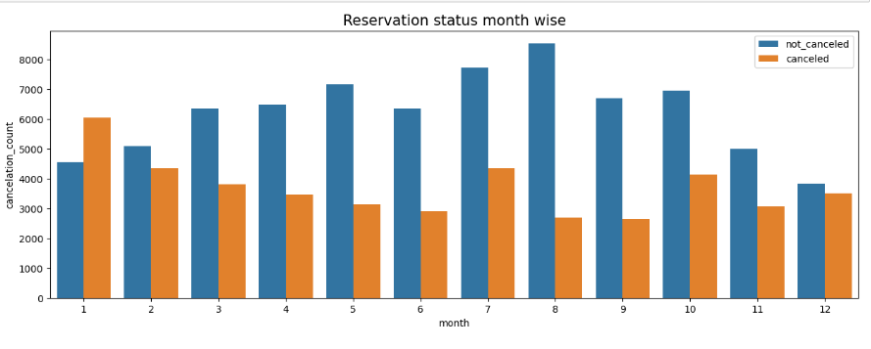

Month wise reservation data shows that highest cancelation occurred in the month of january where lowest cancelation occurred in the month of October.

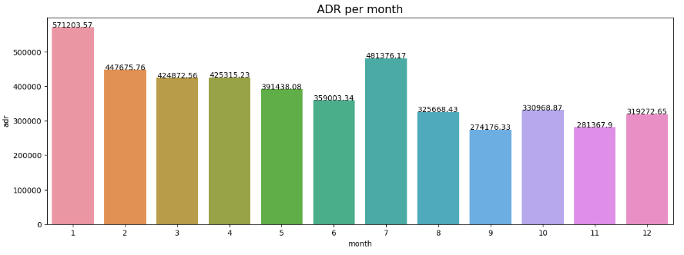

Average daily rate for january month is highest where it’s lowest for the october month. From above two graph it is understood that cancelation depends on the price of the reservation. Cancelation seen more during higher reservation price.

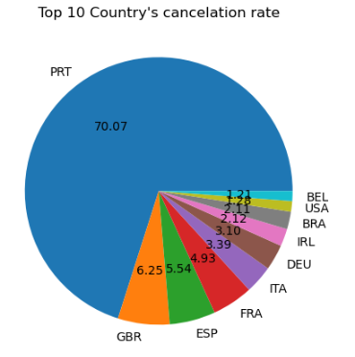

Above pie chart shows country wise cancelation rate . PRT, GBR and ESP are top 3 countries where cancelation rete is higher.

Also, approx 47% customers prefers to make reservations via online TA, approx 20% via offline TA and approx 10% prefers direct reservations.

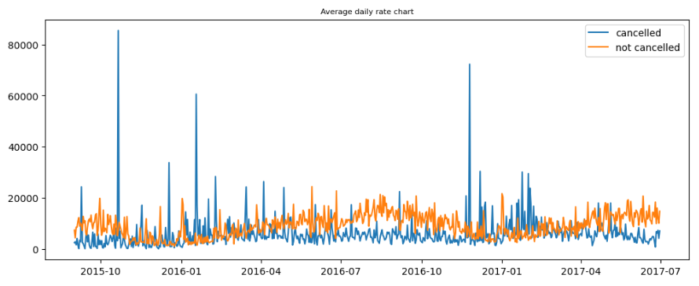

Above chart shows reservations are canceled when average daily rate is higher than when it is not canceled.

Above analysis shows that higher reservation price impact cancellation.